Qiming Jin

11/26/2019

IT FDN 100 A Au 19: Foundations Of Programming: Python

Assignment 08

# Knowledge Document

## Assignment

## Starter code "Assigment08-Starter.py" is provided on Canvas. Read and understand the pseudo-code, then add code to make the application work. Make sure to include error handling.

## Steps

1. Create products.txt in the local.
2. According to the template, create a function AddData() under class Product to add the new row to list/table.

*#* ***TODO: Add Code to the Product class*def** AddData(lstRow):  
 lstRow=[productname, productprice]  
 list_of_product_objects.append(lstRow) print(**"Data is added!"**)

1. According to the template, create two functions accordingly to realize the data storage and reading under class FileProcessor.

*#* ***TODO: Add Code to process data from a file*def** read_data_to_file(file_name, list_of_rows):file = open(file_name, **"r"**)  
 **for** line **in** file:  
 data = line.split(**","**)  
 line = [data[0],data[1]]  
 list_of_rows.append(line)  
 file.close()  
 **return** list_of_rows

*#* ***TODO: Add Code to process data to a file* def** save_data_from_file(file_name, list_of_product_objects):  
 file = open(file_name, **"w"**)  
 **for** row **in** list_of_product_objects: file.write(str(row[0])+**','**+ str(row[1])+**"\n"**)  
 file.close()  
 print(**"Data was saved!"**)

1. Create a series of functions under Class IO to process data’s input and output.
   1. Add docstring for different class.

*#* ***TODO: Add docstring***

**def** add_docstring(classname):  
 print(classname.__doc__)

* 1. Show menu to user.

*#* ***TODO: Add code to show menu to user*def** show_menu():  
 print(**'''  
 Menu of Options  
 1) Show current data in the list of product objects  
 2) Add add to the list of product objects  
 3) Save current data to file and exit program  
 '''**)  
 print()

* 1. Get user’s choice.

*#* ***TODO: Add code to get user's choice*def** get_choice():  
 choice = str(input(**"Which option would you like to perform? [1 to 3] - "**)).strip()  
 print()**return** choice

* 1. Show current data.

*#* ***TODO: Add code to show the current data from the file to user*def** show_current_data_from_file(list_of_objects):  
 print(**"******* The current data: *******"**)  
 **for** row **in** list_of_objects:  
 print(**' '**+str(row[0]) +**','**+ str(row[1])+ **"\n"**)  
 print(**"*******************************************"**)  
 print()

* 1. Get product’s name and standard price from user. Add error handling code as well.

**def** get_product_data ():  
 **try**:  
 **global** productname  
 productname = str(input(**"What is the product's name? "**))**global** productprice  
 productprice = float(input(**"What is the product's standard price? "**)) lstRow = [productname, productprice]  
 print()  
 **return** productname  
 **return** productprice  
 **except** Exception **as** e:  
 print(**"There was an error! Double check the format of your input."**)  
 print(e,e.__doc__,type(e),sep=**'\n'**)

1. Create the main body.

*#* ***TODO: Add Data Code to the Main body***FileProcessor.read_data_to_file(strFileName, list_of_product_objects)

**while**(**True**):  
 IO.show_menu()  
 strChoice = IO.get_choice()  
  
 **if** (strChoice == **'1'**):  
 IO.show_current_data_from_file(list_of_product_objects)**continue  
  
 elif**(strChoice == **'2'**):  
 IO.add_docstring(Product)  
 IO.get_product_data()  
 Product.AddData(list_of_product_objects)  
 **continue  
  
 elif** (strChoice == **'3'**):  
 IO.add_docstring(FileProcessor)  
 FileProcessor.save_data_from_file(strFileName,list_of_product_objects)  
 **break**

1. Run the script in OS command/shell window and test if it works.

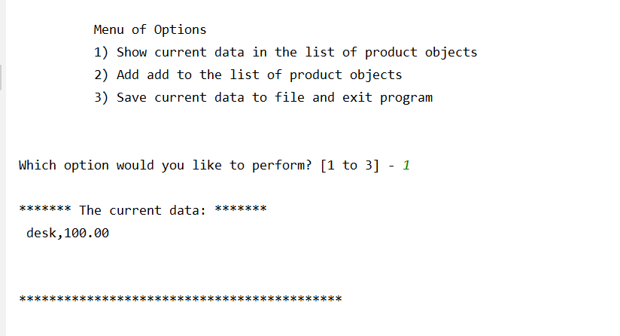

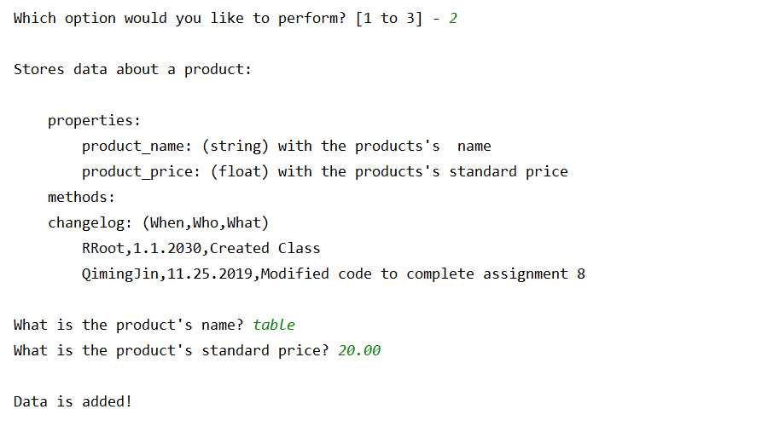

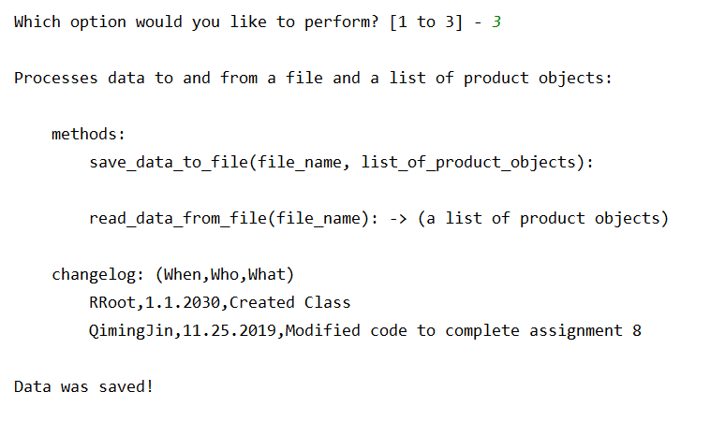

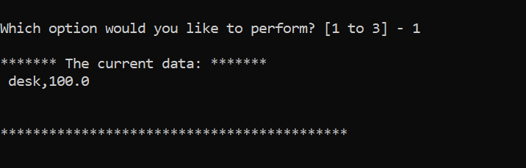

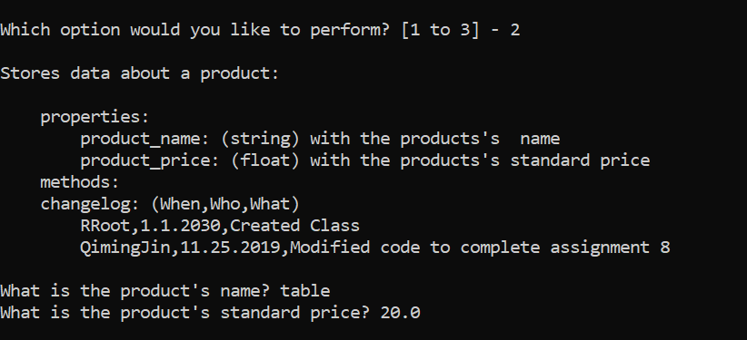

1. Check the data in text file.

